**Equal Experts Hotel Exploratory Testing Activity**

**Version Control**

|  |  |  |  |
| --- | --- | --- | --- |
| **Date** | **Name** | **Role** | **Version** |
| 19/07/2018 | Chris Warren | Software Tester | 1.0 |

**Introduction**

Equal Experts have created a hotel booking form that can be used to create and delete bookings for their hotel.

**Purpose**

The purpose of this document is to demonstrate the exploratory testing activities that have taken place up to date on the Equal Experts Hotel Booking form. The document includes evidence of testing, recommendations for further testing and recommendations for further development.

**Exploratory Testing**

**Data Input**

Please view the spreadsheet file accompanied with this report: Test Scenarios.xlsx. This includes details of tests carried out to test the data input fields. Tab ‘Standard Data’ contains the data used for all tests unless otherwise stated in the Data column in the ‘Test Scenarios’ tab. Below is a screen grab to evidence the bookings that were created during this testing.

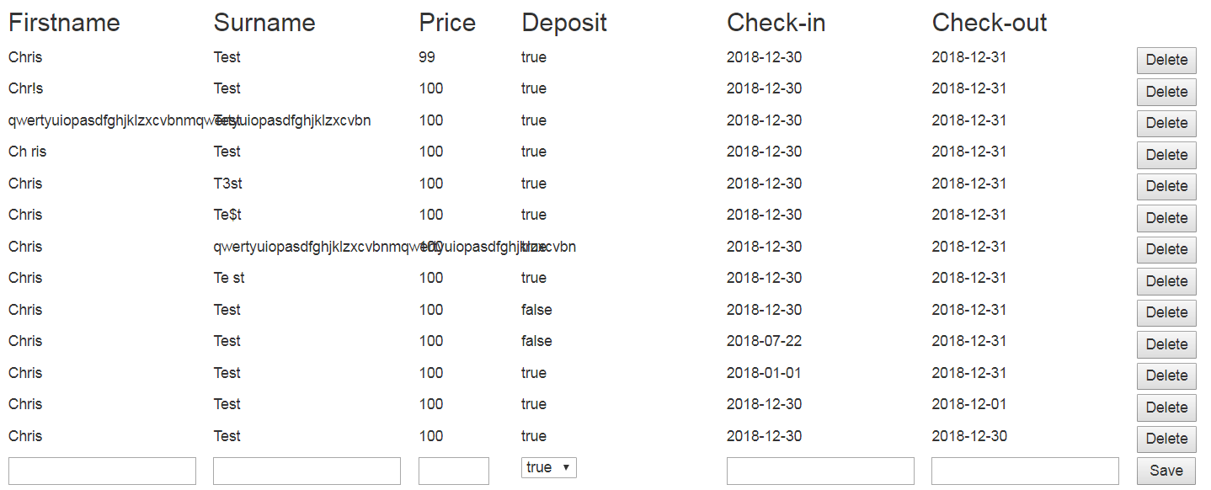

**Delete Booking**

Test Scenamrios.xlsx also includes details of testing around deleting a booking both within the original session and when deleting a booking in a different session.

**Cross Browser Testing**

Testing was carried out in the following versions:

**Chrome v67**

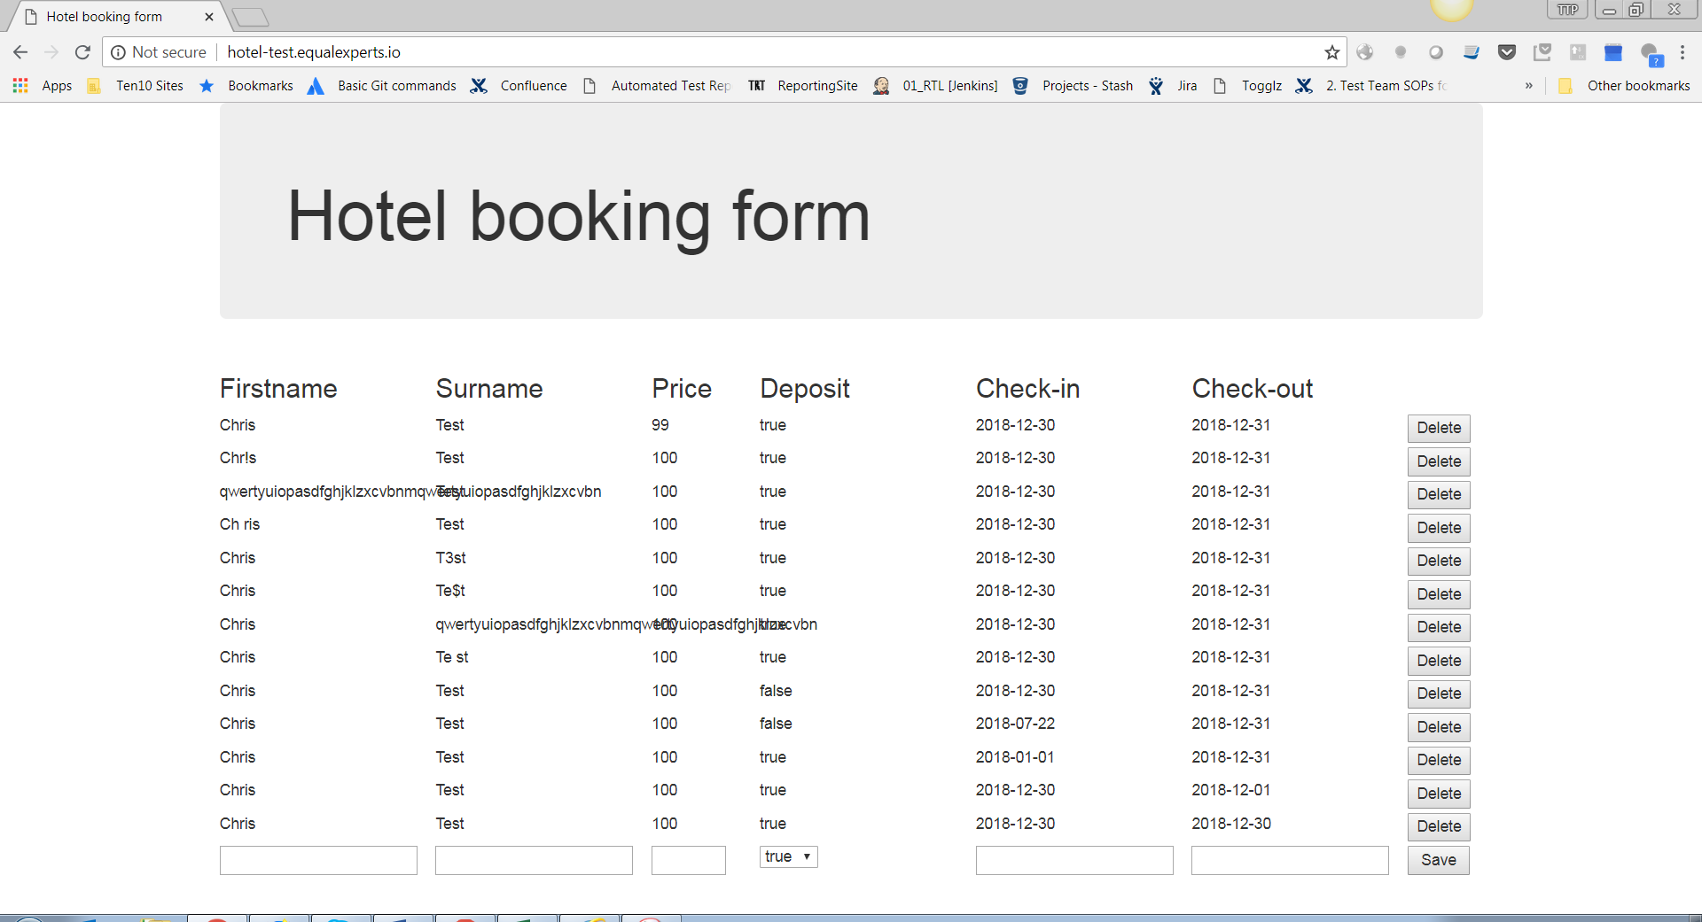

**Firefox v61**

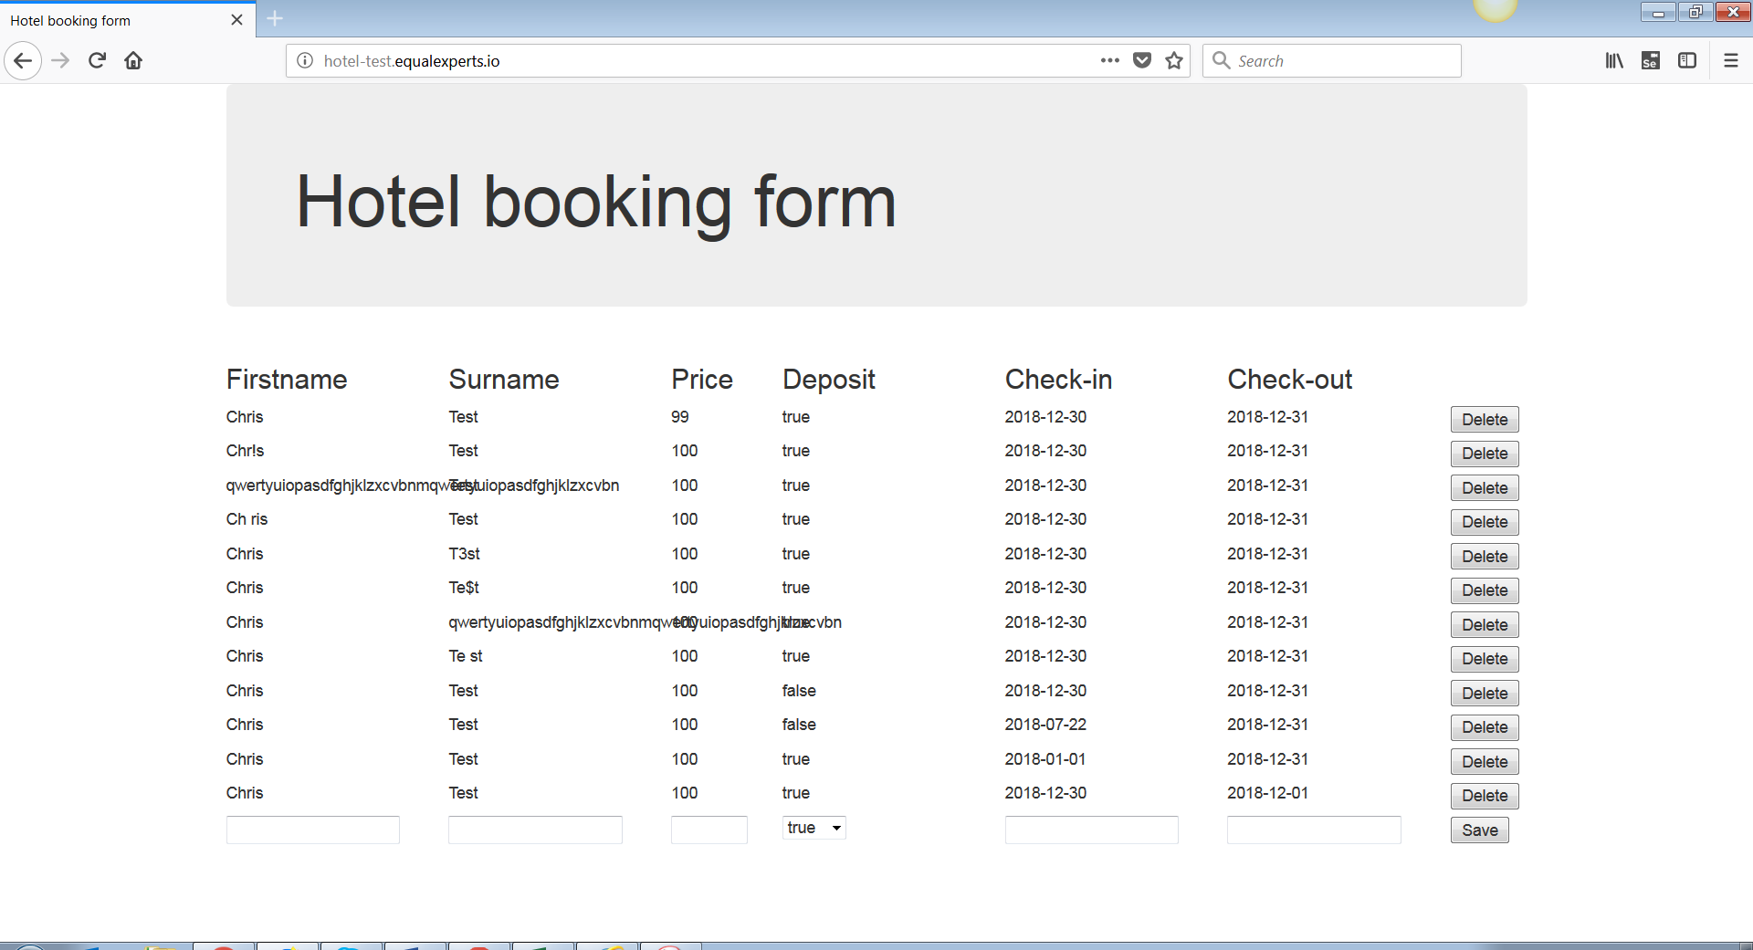

**Internet Explorer v11**

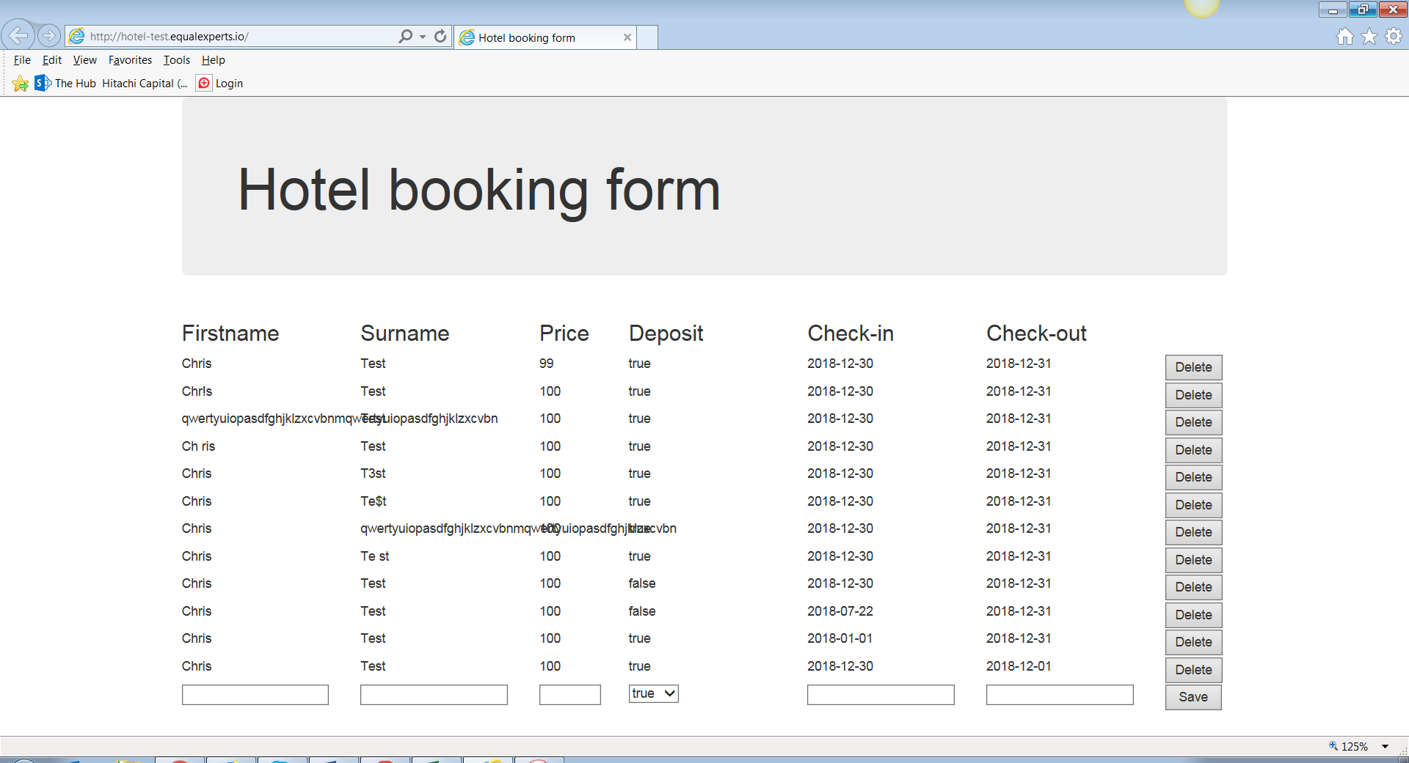

No cross browser issues were found during this testing.

**Rendering / Appearance**

Application fails to render correctly if the browser is resized. At first the rendering impacts the display of the booking information.

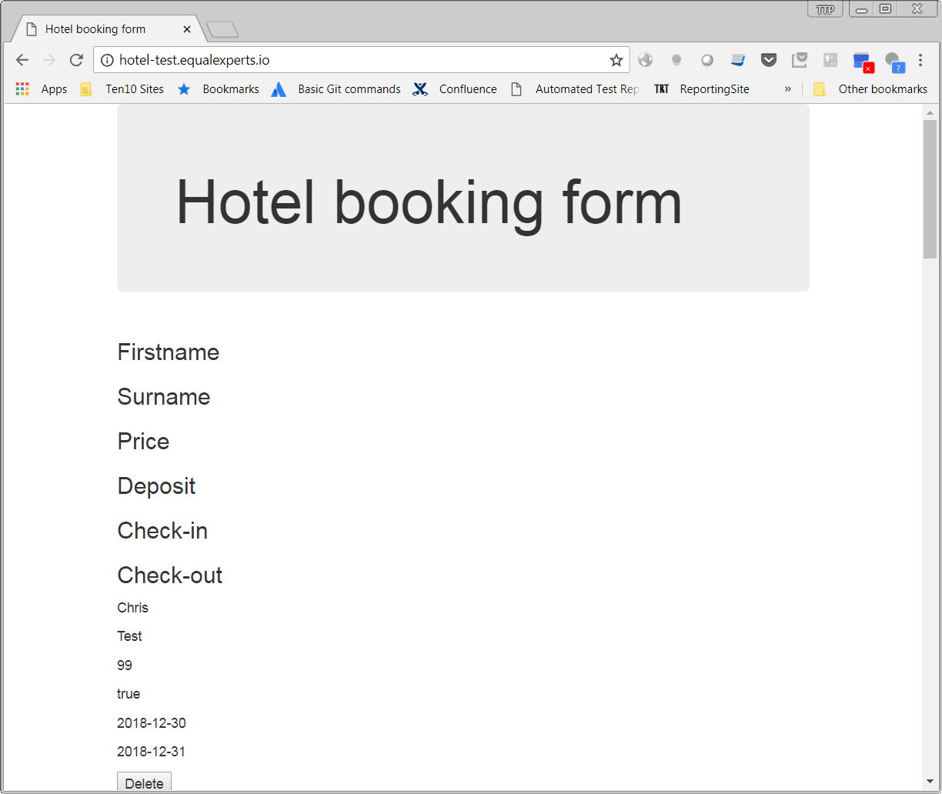

Further resizing of the bowser begins to affect the Hotel Booking Form heading.

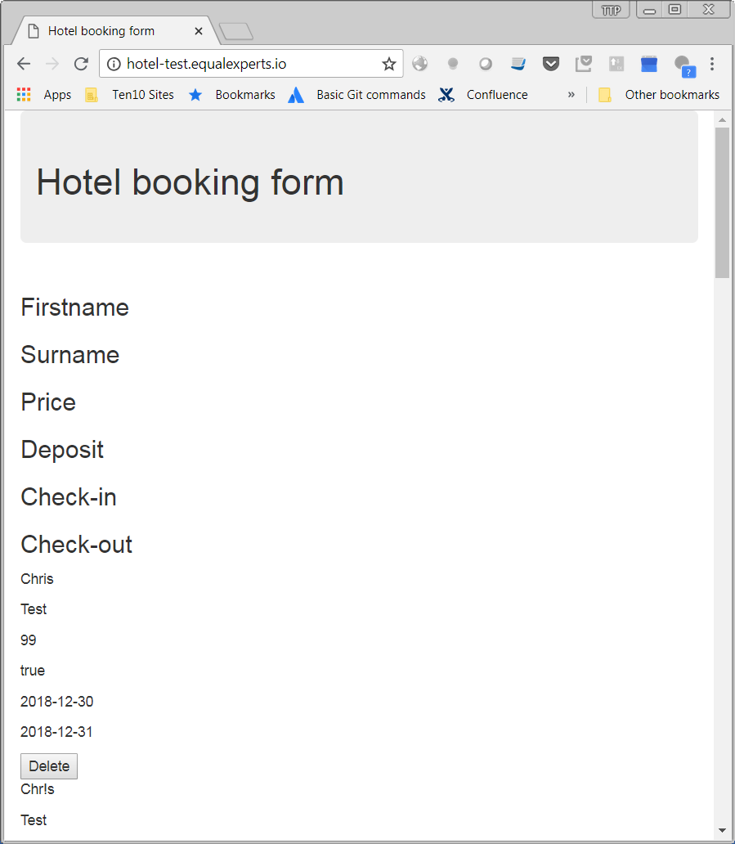

Rendering issues are also an issue when running in the application through a mobile emulator suggesting the application would not be suitable for mobile device usage.

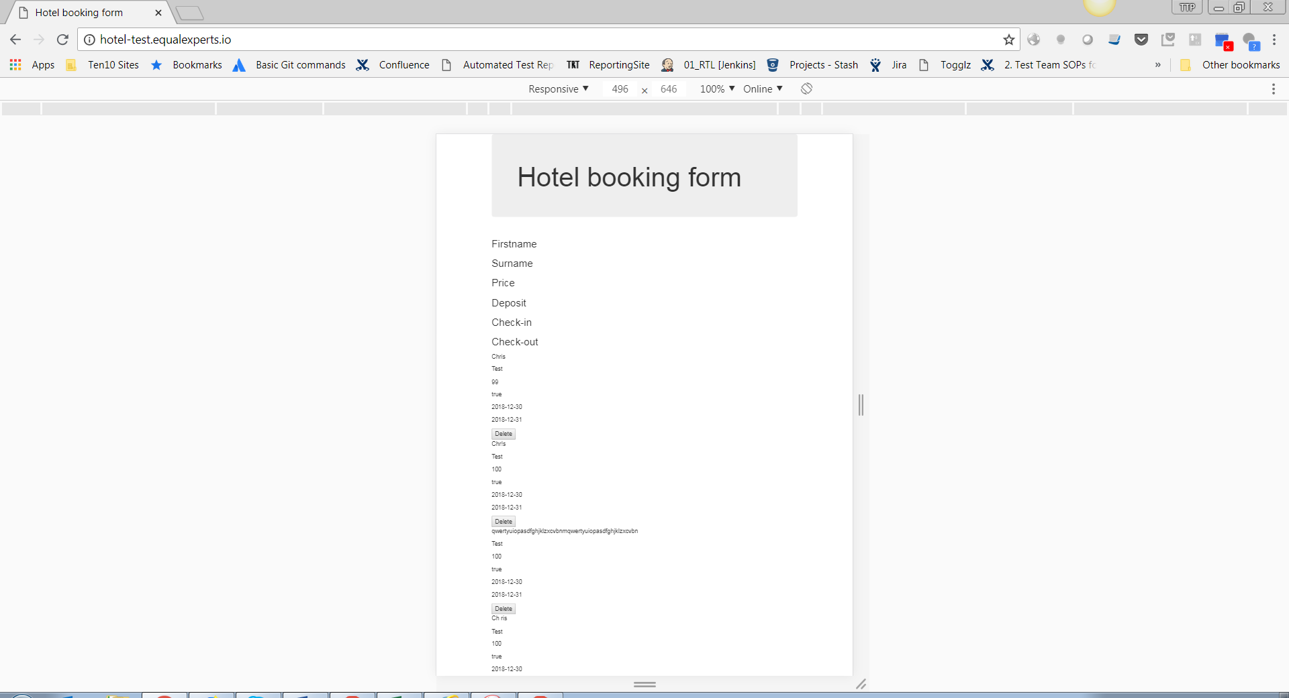

**Security**

The application is vulnerable to Cross Site Scripting attack which is one of the vulnerabilities listed in the OWASP top10. Below you can see that a booking was created with a First name of “<script>alert(“Hello World”)</script>”. Every time the booking information is loaded the JavaScript entered in place of the first name is executed. Although this particular instance is pretty harmless the vulnerability could be used to execute more malicious code.



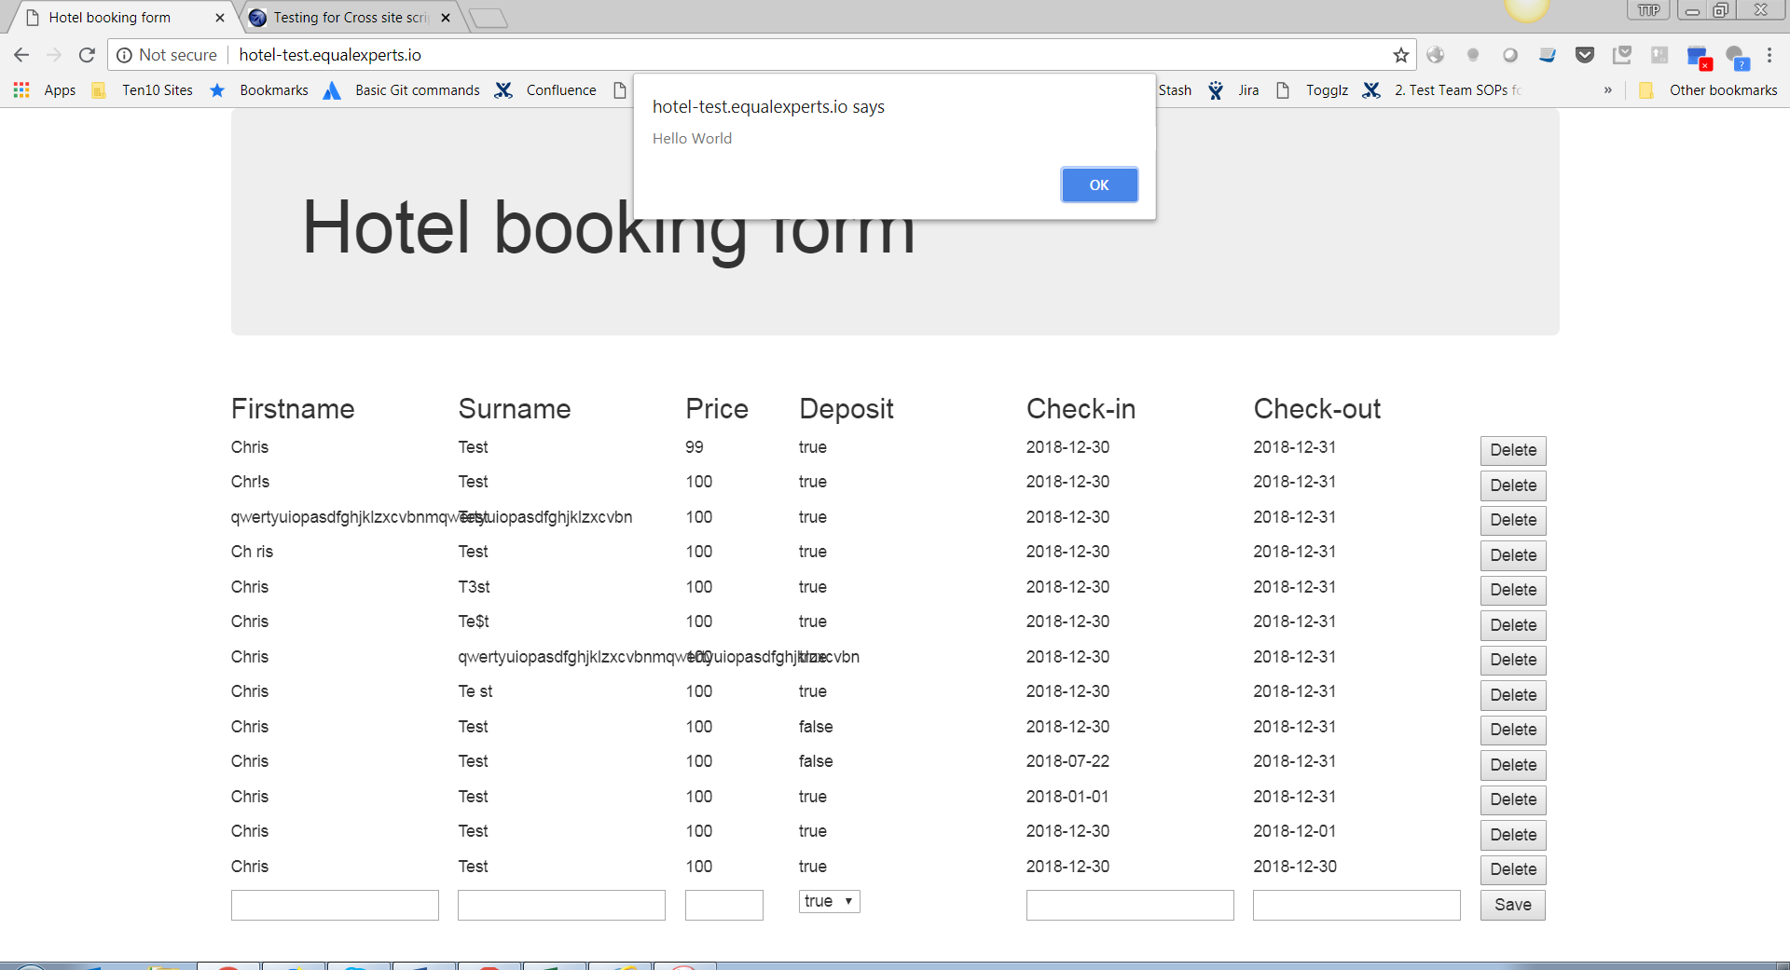

**Recommendations for Further Testing**

**SQL Injection**

I would recommend attempting to create a record that contained “; DROP TABLE Bookings” in an attempt to see if by exploiting SQL injection it would be possible to delete the table that holds the booking information. Please note this testing would require some support from a DBA as a backup of the database would need to be taken and the database restored should the testing uncover that SQL injection is indeed an issue.

**API Testing**

Testing the integration points could be done without invoking the application frontend. An API test pack could be assembled using a tool such as Postman to test if bookings are created, retrieved and deleted.

**Performance**

There is a lag when bookings are being created and deleted. I would recommend that some performance testing is carried out to ascertain whether this lag increases under load. Equal Experts would be required to provide information on what usage they would expect for the system and what response times they would be hoping the application to achieve.

**Recommendation for Further Development**

**Feedback to Users**

On the most part the functionality around creating and deleting bookings is working with the exception of been able to create bookings in the past and setting check out dates to be before check in dates. However users experience would be improved if there was helpful user feedback if a user attempts to create a booking without all mandatory fields completed.

**Potential Issue**

While executing the automation testing against the Equal Experts Hotel application an intermittent issue was noticed. Intermittently the bowser would load the front end which would appear like this:

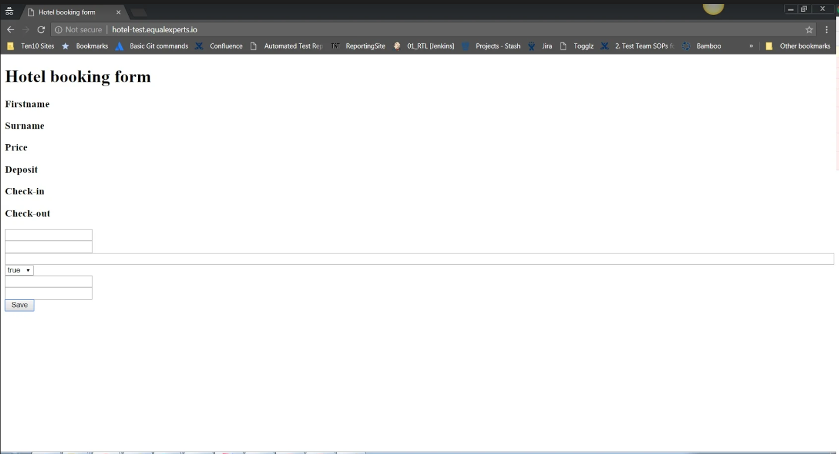

Checking the Console the following errors were captured:

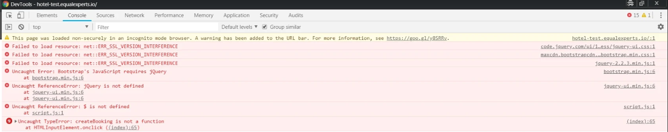

This issue mainly appears when running the automation tests although it has been possible to recreate the issue manually.

As a result of this issue a “hack” work around has been added to the automation testing that will refresh the browser 3 times when the Equal Experts Hotel application is loaded. This is not an ideal solution and it would not be recommended to put this application live while this work around is required. For the time being at least this “hack” does seem to be having a positive impact on the automation testing allowing us to continue to test the functionality of the system.

To investigate this issue further it would be helpful to have access to the applications log files to see if it is possible to see why the application is behaving in this way.